**Extraction of Connected components without using BWLABEL function**

             Many of the visitors to this blog [mailed](http://angeljohnsy.blogspot.in/p/contact-me.html)me to post a **MATLAB**code for extracting the connected components.  In **MATLAB,** a function called **BWLABEL** is available to label the connected components.

Based on the following iterative expression, the connected components are extracted.

[http://3.bp.blogspot.com/-u80Jb1y9S3o/T1Qz_oGc28I/AAAAAAAAAkk/-__uQmenG1A/s320/label_xpr.jpg](http://3.bp.blogspot.com/-u80Jb1y9S3o/T1Qz_oGc28I/AAAAAAAAAkk/-__uQmenG1A/s1600/label_xpr.jpg)where k=1,2,3…

Using the above expression, connected components are extracted without using the function**BWLABEL**

[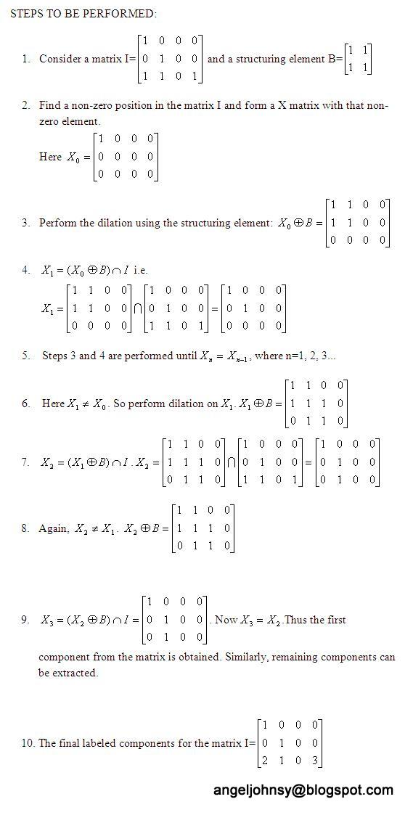](http://3.bp.blogspot.com/-6DGDfqH7P2c/T1Q0OkrOv9I/AAAAAAAAAks/7H629m9462A/s1600/label_procedure-2.JPG)

**LABELLING:**

**MATLAB CODE**:

I=imread('label3.jpg');

[](http://2.bp.blogspot.com/-Eb6QS8I2CkQ/T1Q0qOnViMI/AAAAAAAAAk0/wFRjvG5RBus/s1600/label3.jpg)

I=im2bw(I);

%Structuring element

B=strel('square',3);

A=I;

%Find a non-zero element's position.

p=find(A==1);

p=p(1);

Label=zeros([size(A,1) size(A,2)]);

N=0;

while(~isempty(p))

N=N+1;%Label for each component

p=p(1);

X=false([size(A,1) size(A,2)]);

X(p)=1;

Y=A&imdilate(X,B);

while(~isequal(X,Y))

X=Y;

Y=A&imdilate(X,B);

end

Pos=find(Y==1);

A(Pos)=0;

%Label the components

Label(Pos)=N;

p=find(A==1);

end

imtool(Label);

EXPLANATION:

1. Read an image (A) and convert it into binary image.
2. Define a structuring element (B).
3. Initialize the Label matrix with zeros.
4. Find a non-zero element position in the input matrix A.
5. Initialize a matrix X with zeros and place 1 in the non-zero element position found in the previous step.
6. Perform dilation using the structuring element B on matrix X. i.e. imdilate(X,B);
7. Perform intersection with the matrix A. Y= A&imdilate(X, B).
8. Check whether Y==X. If no, then X=Y and perform steps 6 and 7 again else stop the iteration.
9. Find the non-zero elements position in the Y. In matrix Label place a number N in those positions. N is for labeling the connected components.
10. Similarly, place zero in those positions in the input matrix A.
11. Again find a non-zero element position in the matrix A. If found, goto step 5 else stop the iteration.
12. Using the labels the connected components can be extracted.

**EXTRACTION:**

**MATLAB CODE:**

%Extracting the components

Im=zeros([size(A,1) size(A,2)]);

ele=find(Label==1);

Im(ele)=1;

figure,imshow(Im);title('Label:1');

[](http://1.bp.blogspot.com/-wsnuMpibC5g/T1Q1EomW9wI/AAAAAAAAAlk/ekSblKRaX2U/s1600/component1.jpg)

To obtain the first component, find the positions with value=1 in the Label Matrix. Similarly, other components can be extracted.

%Extracting the characters 'I M A G E'

ele=find(Label==2|Label==3|Label==6|Label==7|Label==9);

Im1=zeros([size(A,1) size(A,2)]);

Im1(ele)=1;

figure,imshow(Im1);title('Specific components');

From the Label matrix, I extracted the characters I, M, A, G and E alone by specifying the label numbers 2,3,6,7 and 9.

[](http://3.bp.blogspot.com/-IWkg2JWnWus/T1Q0rhMkB6I/AAAAAAAAAk8/TM7fWOiduoU/s1600/img_part2.jpg)

%Total number of Letters

Total=sprintf('Total Number of Letters:%d',N);

display(Total);

 The total number of components extracted in the above example Image:

Total =

Total Number of letters:14

%Differentiate each component with a specific color

RGBIm=zeros([size(Label,1) size(Label,2) 3]);

R=zeros([size(Label,1) size(Label,2)]);

G=zeros([size(Label,1) size(Label,2)]);

B=zeros([size(Label,1) size(Label,2)]);

U=64;

V=255;

W=128;

for i=1:N

Pos=find(Label==i);

R(Pos)=mod(i,2)*V;

G(Pos)=mod(i,5)*U;

B(Pos)=mod(i,3)*W;

end

RGBIm(:,:,1)=R;

RGBIm(:,:,2)=G;

RGBIm(:,:,3)=B;

RGBIm=uint8(RGBIm);

figure,imshow(RGBIm);title('Labelled Components');

[](http://3.bp.blogspot.com/-rAD3mVxSRGg/T1Q0yUzu4-I/AAAAAAAAAlU/ESzE5KLWWOA/s1600/label_img1.jpg)

For each label, unique color is given.  Here is another example for labeling and extracting the components. Read the image, ‘coins.png’ , convert it into binary and fill the holes. Then perform labeling and extraction.

[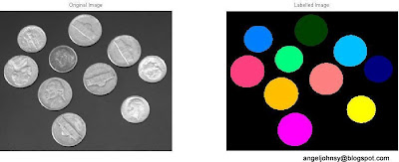](http://2.bp.blogspot.com/-vFuirWPVpbM/T1Q0zpE3f9I/AAAAAAAAAlY/PVHAmDaT5vY/s1600/label_img3.jpg)

Total =

Total Number of coins: 10